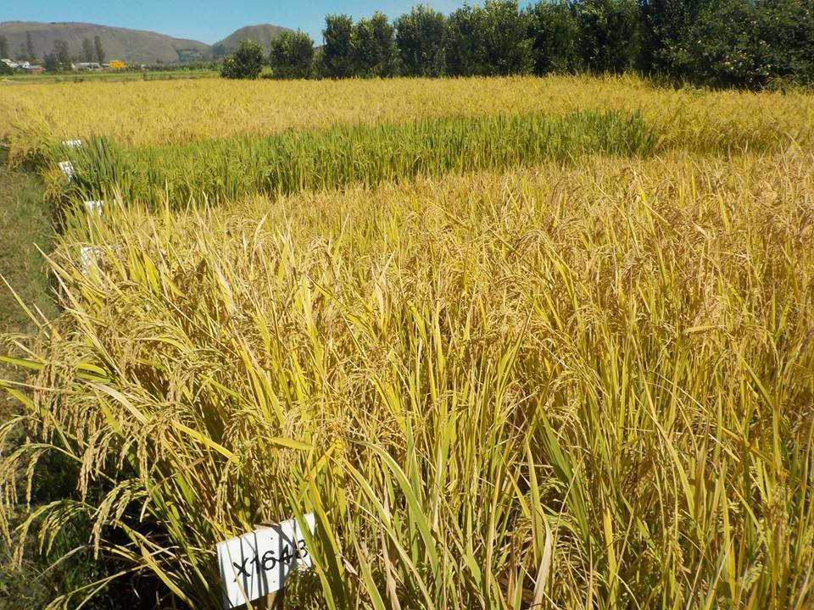

|  |  |  |  |  |  |  |  |  |
| --- | --- | --- | --- | --- | --- | --- | --- | --- |
| |  |  |  | | --- | --- | --- | |  |  |  | |  | |  |  |  | | --- | --- | --- | |  |  |  |   **RAPPORT D'ACTIVITES 2017 DU FOFIFA** |